

Mastering EPM Cloud for Effective Selling

Participant Guide

November 2018

TABLE OF CONTENTS

Lab Overview 4

Individual Exercises 4

Group Recaps 5

Lab 1: EPBCS Financials 5

Exercise 1: Starting Oracle VirtualBox 6

Exercise 2: Navigating in EPBCS 8

Exercise 3: Configuring Financials 13

Exercise 4: Planning Revenues 18

Exercise 5: Planning Expenses 26

Exercise 6: Planning Using Balance Sheets 31

Exercise 7: Planning Using Cash Flow 33

Exercise 8: Analyzing Financials 34

Exercise 9: Shutting Down the Virtual Machine 36

Appendix: Creating Demo Environments 37

1.0 Types of EPM Demo Environments Available 38

Guided Demonstrations 38

Live Demonstrations 39

2.0 EPM Demo Assets Available 40

3.0 Setting up an EPM Demo Environment 41

Example: EPBCS Demo Environment Setup 42

Exercise 1: Load Enterprise Planning (EPBCS) User Groups and Roles 43

Exercise 2: Load Enterprise Planning (EPBCS) Application 47

Exercise 3: Configure the Application (Pre-Demo Setup) 50

Exercise 3-1: Change Application Maintenance Mode 51

Exercise 3-2: Activate Navigation Flows 53

Exercise 3-3: Refresh Database 55

Example: FCCS Demo Environment Setup 56

Exercise 1: Load Financial Consolidation and Close Cloud (FCCS) User 57

Exercise 2: Load Financial Consolidation and Close Cloud (FCCS) 60

Exercise 3: Configure the Application (Pre-Demo Setup) 62

Exercise 3-1: Change Application Maintenance Mode 63

Exercise 3-2: Update Announcement End Date (if needed) 64

Exercise 3-3: Deploy Schedule 65

Exercise 3-4: Submit Tasks 69

Exercise 3-5: Reject Tasks 72

Exercise 3-6: Load Data and Set Drill Through 75

Exercise 3-7: Set POV for Users 78

4.0: Backing up EPM Demo Content 79

## Lab Overview

The lab exercises are designed to complement your training, reinforcing the key concepts by applying and demonstrating what you learn in the presentation sessions. This lab book is comprised of individual exercises. The individual exercises allow you to get first hands-on exposure working with the various Enterprise Performance Management (EPM) Cloud products using a demo environment, where you will see how key features and functionality are deployed in the software. Upon completion of each exercise, a group review of the key takeaways will follow, tying back product content to the sales messaging and positioning.

## Individual Exercises

You will be using a portable virtualized version of the Oracle EPM Cloud environment produced by Development for cloud services that leverage the Planning and Budgeting Cloud platform to run on your computer. As a portable VM with performance highly dependent on the host hardware, recommended scenarios using this VM are for internal, non-public facing activities. For example, the VM may come in handy if you need to troubleshoot a customer issue, document a procedure for your customer or prospect, develop a demonstration or an application, or learn how to use and demonstrate the latest features of EPM Cloud.

Furthermore, this particular VM has been modified for XWeek training purposes. Typically, EPM demo environments do not come with seeded demo applications. This VM contains EPBCS and FCCS applications with pre-seeded and preconfigured content designed specifically to perform the labs written for XWeek in EMEA and JAPAC.

**Prerequisite**: Before coming to this XWeek event, you should have obtained a copy of the Virtual Machine and deployed it on your computer. Refer to the XWeek EPM Cloud VM 16.09 Deployment Instructions for details.

**Application content is driven by external factors such as user data entries and login date. As a result, what you see displayed in your VM may not match exactly with the lab screenshots. Screenshots are provided solely for illustrative purposes to help guide you directionally through the user interface.**

## Group Recaps

Each individual exercise will conclude with a group recap of the lab content tying back to what you learned in the presentations – highlighting key features and functionality to showcase that reinforce product values and benefits. To round out the exercises, EPM SC experts will also share personal insights and best practice demo techniques.

# Lab 1: EPBCS Financials

Oracle Enterprise Planning and Budgeting Cloud (EPBCS) offers a highly configurable framework that can be used out-of-the-box or further enriched to meet unique custom business requirements – all while maintaining the ease and upgradability of a cloud-based planning solution. EPBCS provides four complete, planning and budgeting solutions for Financials, Workforce, Capital, and Projects.

The Financials framework is a fully integrated financial statement planning solution across the income statement, balance sheet, and cash flow. For example, the integration ensures that changes on the income statement automatically roll to the balance sheet and cash flow. Importantly, the Financials framework is constructed into four sub-processes that can be incrementally enabled: Revenue, Expense, Balance Sheet, and Cash Flow. This allows you to use a single sub-process – such as Expense planning – or any combination of the sub-processes in the framework.

Key features and functionality:

* Built-in best practice predefined content
  + - Drivers and key performance indicators (KPIs)
    - Calculations
    - Forms
    - Reports
    - Dashboards
* Ease of use with configuration wizards
* Planning and reporting needs in one centralized repository

**Financials:** Integrated driver-based planning for the Income Statement, Balance Sheet, and Cash Flow

**ATTENTION:** Be sure you are NOT connected to Oracle VPN when running the VM and performing the lab exercises.

## Exercise 1: Starting Oracle VirtualBox

1. Open Oracle VM VirtualBox Manager. Click PBCS_VirtualBox to display details. Verify that the value of **Operating System** under **General** is reported as Oracle (64–bit). If this is reported as 32–bit, verify that virualization is enabled for your system. The settings of this VM are configured under the assumption you are hosting the VM with the minimum hardware of 8 GB memory. The base memory is reduced to the highest value at which VirtualBox stops reporting invalid setting about memory (in this case, recommended no more than 5015 MB of memory to the VM).  
   Oracle recommends that you use a laptop with 16 GB RAM (of which 11 GB is allocated to the VM) if you are working with Oracle Enterprise Planning and Budgeting Cloud or Oracle Financial Consolidation and Close Cloud.
2. If your laptop is greater than the minimum memory, you can change the VM settings. For example, for a laptop with 16 GB RAM, 11 GB can be allocated to the VM. Click Settings. Under System, change the Base Memory as desired.

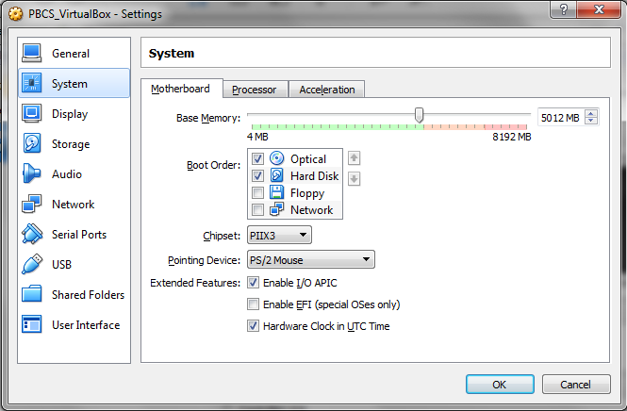

1. Click **OK** after correcting settings.
2. Click **PBCS_VirtualBox (Snapshot 2 – EPBCS)**. Click the **Start** arrow to to start up the image with its latest state.

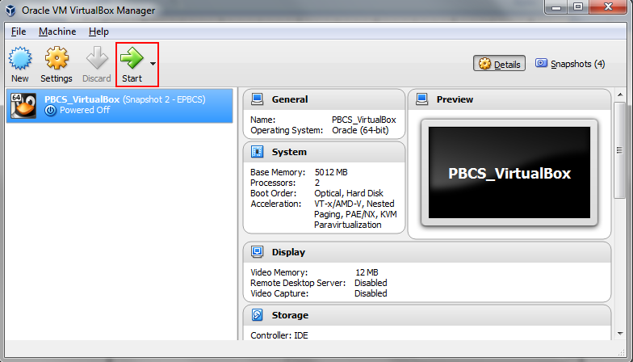

1. Oracle Linux 5 VM operating system starts. You do NOT need to log into this operating system. The Oracle EPM cloud service starts automatically in the background after the VM operating system boots up.

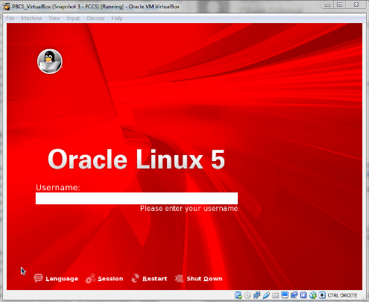

The EPM service becomes available a few minutes after the VM starts. The time it takes for the service to be available depends on the performance capabilities of the host computer. With 8 GB RAM laptop, this may take 7-8 minutes. Once you get the red Oracle Linux screen, you do NOT need to log in. Just keep this VirtualBox window open.

## Exercise 2: Navigating in EPBCS

1. On the computer that hosts the VM, start a browser session and connect to the following URL: <http://192.168.56.102:9000/HyperionPlanning>. Note: 192.168.56.102 is the default IP address of the host-only Adapter that VirtualBox is configured. If you cannot connect, this means the EPM cloud service has not finished starting up. Wait a few minutes more, and refresh your browser session.
2. The EPM Cloud login screen should be displayed. Portable VM performance is highly dependent on the host hardware, so response times may vary. With miminum hardware (8 GB RAM, no SSD), it may take 25-30 seconds to pass the web browser login page.

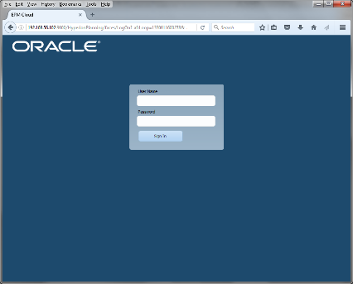

1. Log into the environment as the administrator **demoadmin\epmDem0s** . Click **Sign In**.
2. With minimum host hardware, the first screen (initial cold start time of the VM) may take up to 8 minutes to render. After this, it should be a lot faster to browse through the product (e.g., 60 seconds for subsequent web form). Review the Home screen. The user interface is standard across all EPM Cloud Service products. Some navigation terminology:

**“SPRINGBOARD” (AKA ‘Home Screen’)**

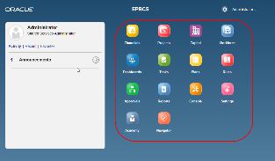

**“CLUSTER”**

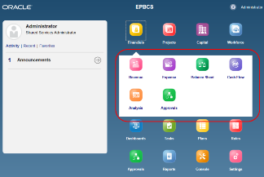

**“FILM STRIP”**

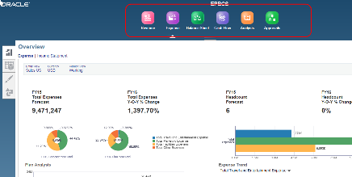

**“RETURN TO SPRINGBOARD”**

Click either the Oracle logo in the upper left corner (or your custom logo) or the Home icon.



**EPBCS Lab Structure**

EPBCS is a perfect solution for both corporate finance as well as operational planners throughout the enterprise (e.g. sales, marketing, HR, IT, and the lines of business, etc.). It empowers operational planners with flexibility, scalability and the ownership to plan the way they want, while still offering the transparency and control required for corporate finance.

The following lab exercises walk you through basic planning activities from two perspectives showcasing product benefits:

**Administrator (Finance)** – Highly configurable solution you can leverage built-in best practices and yet further tailor for your unique planning requirements over time. You have full visibility and control of department plan submissions and their financial impact at the consolidated company level.

**Planners (Line of Business)** – Easy to use tools to plan at an operational level of detail (revenues, expenses, human and capital resources, projects) using various modeling techniques (drivers, trends). Federated solution allows sharing of data and collaboration between planners.

Upon logging in, you see the latest updates and notifications. You also have the ability to quickly navigate to recently used dashboards, reports, and templates – as well as mark key content as favorites.

As with all Oracle Cloud services, you have access to icons on the main page so you can quickly perform a variety of commonly-used functions. Here you can access your **Tasks**, budget entry forms (also known as **Plans**), **Approve** Budgets, generate **Reports** and view **Dashboards** among other functions.

The centralized repository gives you access to all the information you need for planning and reporting in one location – eliminating the need for your team to cobble together information from disparate spreadsheets and emails.

Planning was designed to be intuitive and easy to use. As such, you’ll see many features that simplify planning and reporting:

* **Task Lists** to guide users through the planning/forecasting process
* Quick links to **Dashboards** and **Reports**
* **Settings** is where users set up their preferences for numerical formatting and notifications
* The **Academy** is a collection of how-to videos and tutorials to ensure that you get the maximum value from your investment

EPBCS has four configurable planning frameworks: Financials, Projects, Capital, and Workforce. This lab covers Financials. The remaining three frameworks are covered in subsequent labs.

**Note:** The EPM Cloud User Interface changed in version 16.09 (version running on this VM). However, custom navigation flows (i.e., not the default) do not get upgraded to the new User Interface in this release. The upgrade will most likely occur in 16.10. The demo content which this EPBCS lab is based on uses a custom navigation flow. **So for our training purposes, the EPBCS User Interface has been reverted to the 16.07 User Interface.** The FCCS lab uses the 16.09 User Interface. As a result, you will see minor differences in what is displayed on the Home page for the two products – e.g., In 16.09, Console card is removed and replaced with Application card, Settings card with Tools card.

**What you see displayed in your VM may not match exactly with the lab screenshots. Screenshots are provided solely for illustrative purposes**.

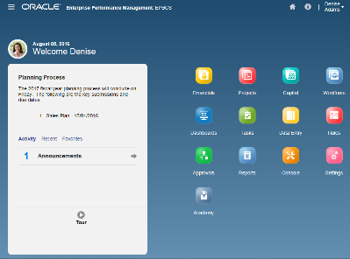

## Exercise 3: Configuring Financials

Financials delivers tools to help you quickly develop plans and forecasts, and generate core financial statements for internal analysis. Financials provides these components that you can enable incrementally to best meet your business needs:

Revenue / Gross Margin

* Expense
* Balance Sheet
* Cash Flow
* Income Statement
* Analysis

Financials integrates with Capital, Workforce, and Projects so that planners can create very granular plans, forecasts, and financial reports that include different types of data.

1. On the Home page, click the **Console** card. Click the **Configure** vertical tab (fourth from bottom).

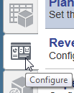

1. EPBCS intuitive business wizards make it easy to ‘enable’ only the features that you want, then to quickly configure calculations and processes. In the Configuration page you can enable the four built-in business processes. They can be used in their entirety or mashed-up with configured processes to quickly deliver value. You can enable any of these four business processes or integrate between the business processes. In this case, since seeded content has already been loaded in the EPBCS environment, all four processes are already enabled.

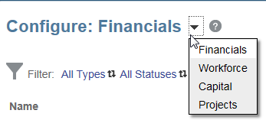

1. With the Configuration page on Financials, click **Enable Features**. Best practice is to enable only the features that planners currently require. The highly configurable framework allows you to easily enable more features later. Here, Financials provides an application framework that uses driver-based, trend-based, and manual accounts that fully integrate with your income statement, balance sheet, and cash flow statements. Click **more** links to read more details on the types of predefined dimensions and accounts created.

Hint: Do not click **Enable** button as this starts the process to enable additional features which is not necessary for this exercise.

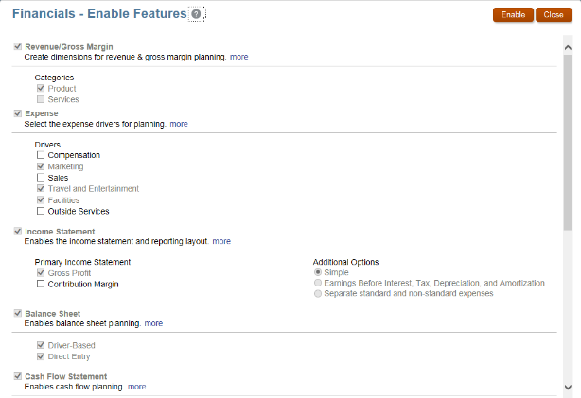

1. Click **Close**.
2. Click **Revenue Accounts**.

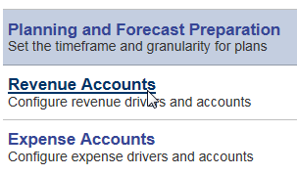

Each business process uses a similar method that enables you to create, modify, and manage accounts and drivers.

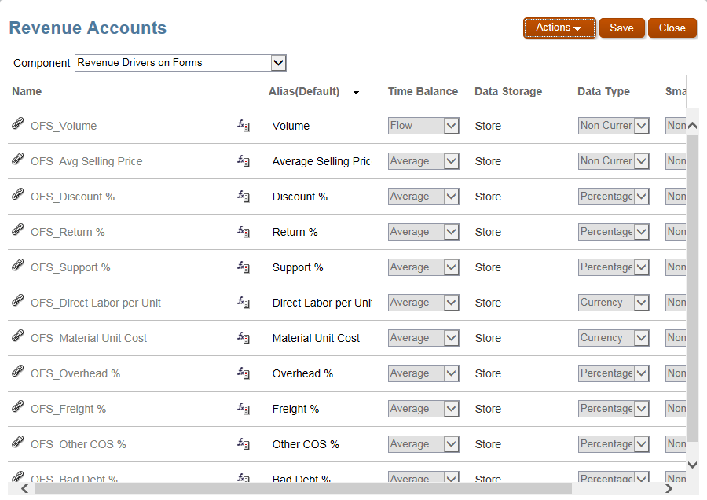

1. Check out the different components for Revenue Accounts by selecting from the drop-down list.

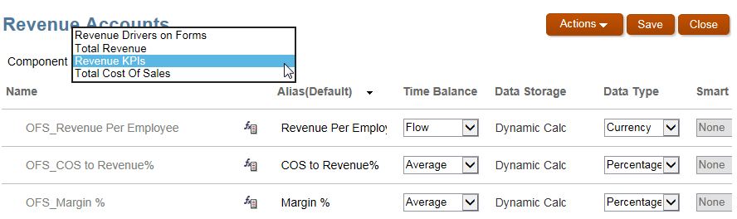

1. Click **Close**.

## Exercise 4: Planning Revenues

EPBCS offers a configurable ‘framework’ for revenue/gross margin planning by ‘Flex Dimensions’ such as Product, Market, Customer, etc.

1. Click the **Financials** cluster. To decrease time to value, Financials provides an application framework that uses out-of-the box driver-based, trend-based, and direct-input accounts that fully integrate with the income statement, balance sheet, and cash flow statements.

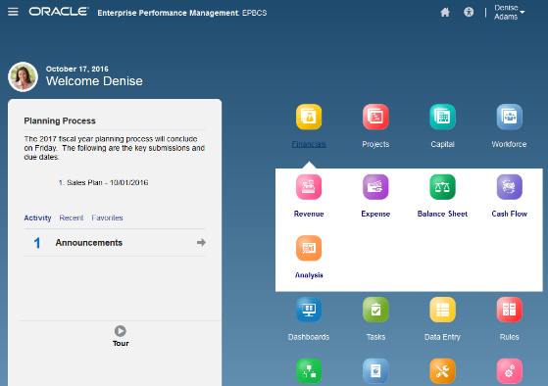

1. Click the **Revenue** card. Portable VM performance is highly dependent on the host hardware, so response times may vary. With minimum hardware (8 GB RAM), it may take 60 seconds or more to open your first dashboard. Opening of subsequent dashboards will be quicker to render. Be sure the POV is set to **Sales US, Working, USD**.

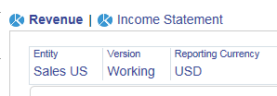

If you need to change the POV, click the member name link and use the Member Selector to make the change. Remember to click to the left of the member name to set the little check mark.

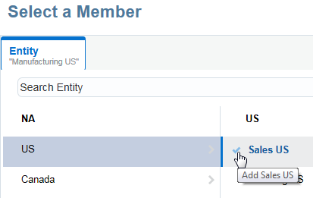

1. Click the Show/Hide line at the top of the screen to expand the dashboard.

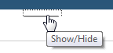

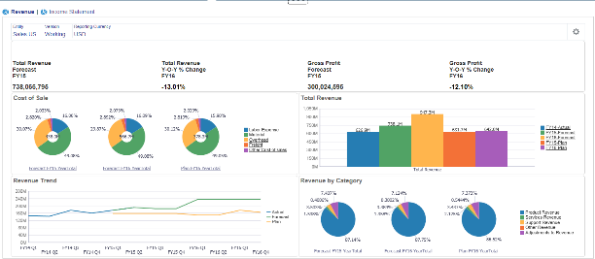

The **Overview** vertical tab (where you are now), provides pre-built, interactive dashboards – including visualizations for Revenue and Gross Profit. These can be further configured to meet specific needs. These **Navigation Flows** are available out-of-the-box to facilitate an efficient planning and forecasting process by organizing all of the information that you need in an intuitive manner. The Revenue dashboard displays historical trends and breaks down revenue by category

1. Click the horizontal tab titled **Income Statement** Dashboard. This dashboard displays revenue as it relates to other income statement components. Review its contents.

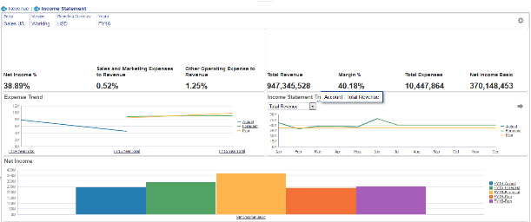

1. On the left, there are a series of tabs to aid navigation through the Planning process, accessible based on security. These **Navigation Flows** are consistently employed throughout the application as you enable new capabilities over time. Click the **Driver and Trend Based** vertical tab (second from top).

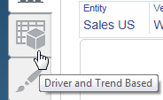

EPBCS supports driver based and trend based revenue planning. There are a number of drivers and trends that are supported out-of-the-box. These drivers, enabled by the administrator, determine how you will set, track, and analyze accounts. You can specify driver values using trend assumptions or by manually entering them.

1. On the **Driver Based Revenue Planning** form (first horizontal tab), review the layout: tabs across the top, POV, read only versus write cells. Make sure **Entity** dimension is set to **Sales US** (make sure you click the check mark to the left of the member name). Here you can review and adjust driver values for recurring line items – add a % increase/decrease to the trend resulting in the **Calculated Trend Value**, or make a value adjustment to a driver.
2. Adjust a driver.
   * + In the POV, select **FY16, Smart Phone 4** in, **US Market** and the **→** key to refresh.
     + **Volume →** Click **+** to expand the **YearTotal Adjustment** column.
     + Change **$1,000** to **2K** – See how the year total automatically spreads back to the corresponding quarters based on the existing amounts that were already there for each month. This is a great way to incorporate seasonality or common trends. Many customers will load last year’s actual values as a starting point for the budget and then enter an updated annual amount, which will be spread using the actual. This approach also speeds up data entry for the budget user.
     + Click the **Save** icon. Hint: You may need to hover over the white space above the data entry until the icons display. With minimum host hardware (8 GB RAM, no SSD), it may take 25-30 seconds for the first save, and then it should be relatively fast across all other contents.

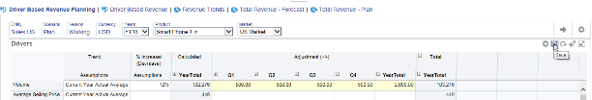

1. Drill on **Gross Profit** chart. Drill on **Total Revenue**. Hover over **Product Revenue**. You can quickly visualize the results of your planning in real time by drilling into the accompanying charts.

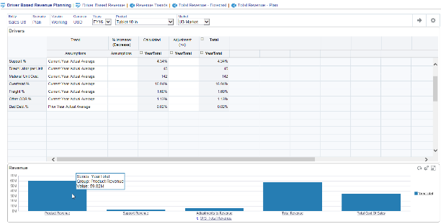

1. Click the **Driver Based Revenue** form (second horizontal tab). You can see the extrapolation of the driver-based revenue in a tabular format and can make further adjustments to the Calculated Revenue Plan.
2. Enter a value in the **Adjustment** column and click **Save**.
3. Click the **Data** tab. Click the **Comments** icon. Enter a comment and click **Post**.

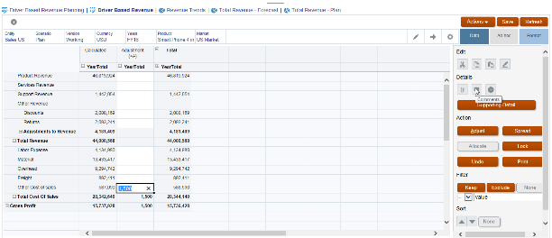

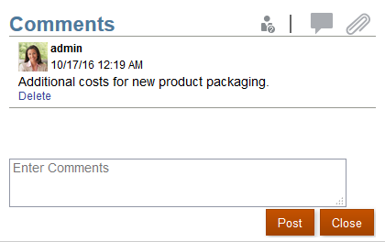

All information in a centralized location that is easily accessible, including visibility into who changed what when.

1. Click the **Direct Entry** vertical tab (third from the top). For those that choose not to leverage the driver-based or trend-based revenue planning, you can enter data directly. Here you can enter miscellaneous or non-driver calculated expenses or revenues.

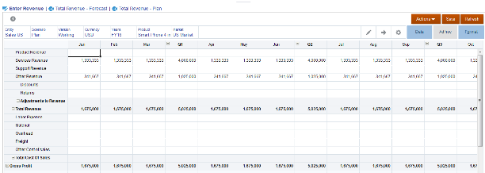

1. Click the **Total Revenue – Forecast** and **Total Revenue – Plan** forms (second and third horizontal tabs). All of the data is summarized and can include both Forecast and Actual data.

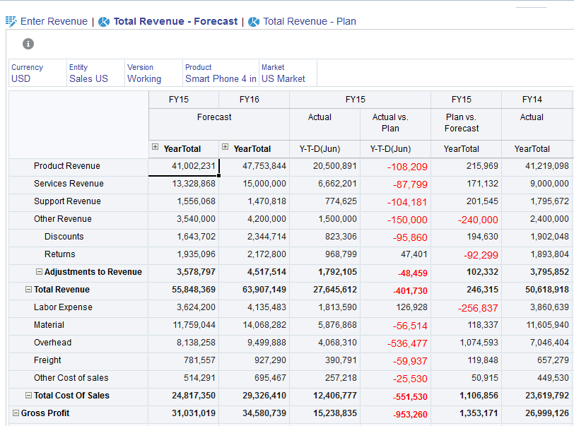

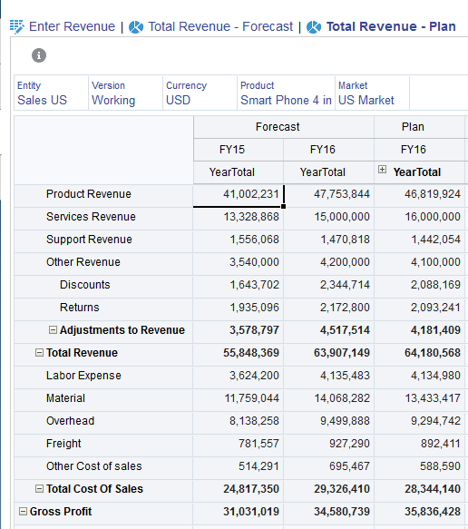

## Exercise 5: Planning Expenses

EPBCS offers a configurable ‘framework’ for driver based & trend based expense planning.

1. As with Revenue Planning, you can quickly visualize the results of your expense plan in real time and explore your data. Click the **Expense** card either by clicking the Show/Hide line again or clicking on the **Navigator** icon in the upper left and clicking on the **Expense** link.

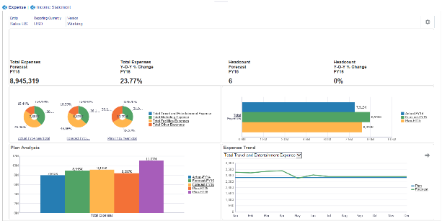

1. Hover the cursor in the upper right corner of the doughnut chart to see a menu of options. Click the **Maximize** icon in the doughnut chart.

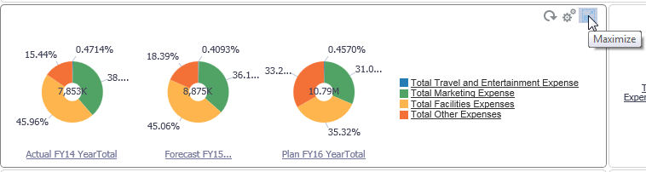

1. Drill down on **Marketing Expense** in the **Plan FY16** chart. In this scenario, marketing expense is expected to grow for the next fiscal year due to the launch of a new product line. You can see the detail on the expense for Marketing Events planned.

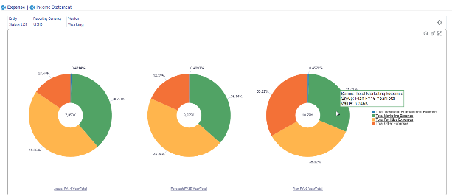

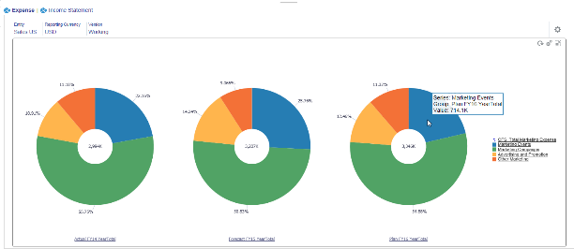

1. Click the **Restore** icon to return to the dashboard.

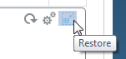

1. Click the **Driver and Trend Based** vertical tab (second from top).



1. In the Driver Based Expense Planning form (first horizontal tab), make sure **Entity** dimension is set to **Sales US** (make sure you click the check mark to the left of the member name).
2. Change trend assumption to base costs on more recent data:
   * + In the POV, set dimension Expense Drivers = **Marketing Expense Drivers** and Expense Account = **Total Marketing Expense** (make sure you click the check mark to the left of the member name) and click the → key to refresh.
     + **Cost per Event →** Note the existing value 7,438 in the Calculated column. Click the Assumptions drop down.
     + Change the entry to **Current Month Actual**.
     + Click the **Save** icon. See the Calculated value change to 9,054.

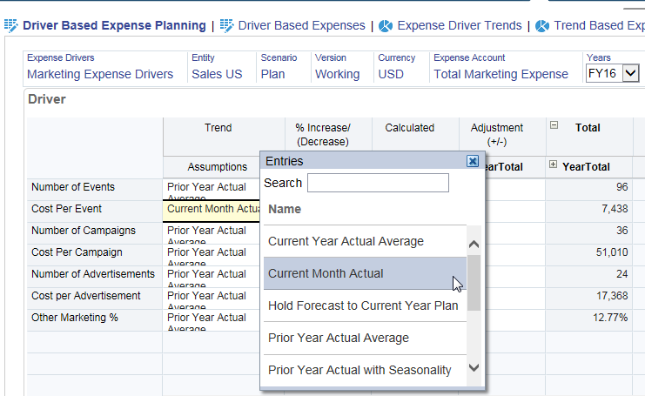

1. Click **Driver Based Expenses** form (second horizontal tab). Again, you can see the calculated values in grid format and make further adjustments if needed.

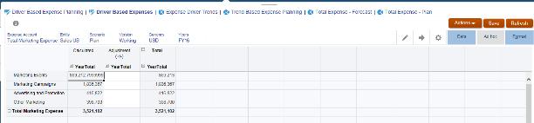

1. Click the **Trend Based Expense Planning** horizontal tab and scroll down below Total Compensation. For those accounts that aren’t driver-based, you can leverage out of the box trend-based expense plans. Just like the drivers, select the trend – you have the ability to adjust the trend up/down by a % or make an adjustment to the calculated value.

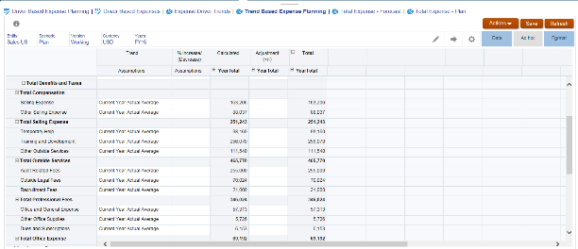

1. Click **Total Expense – Plan** horizontal tab. This form provides a pre-built summary of the overall expense plan. Note the Total Marketing Expense for FY16 is 3,521,102 after you made the change in trend assumption for Cost per Event in step 7.

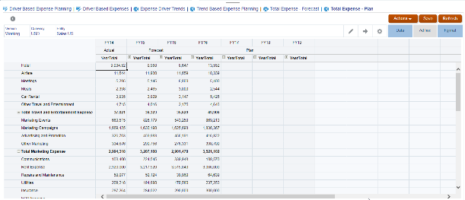

1. Click the **Income Statement** vertical tab (bottom).

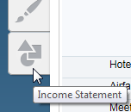

1. Review the POV. The plan data flows to the pre-configured Income Statement and updates with latest YTD values.

## Exercise 6: Planning Using Balance Sheets

EPBCS offers a configurable ‘framework’ fully integrated with Income Statement and Cash Flow – configurable for industry -specific requirements.

1. Click the **Balance Sheet** card either by clicking the Show/Hide line again or clicking on the **Navigator** icon in the upper left and clicking on the **Balance Sheet** link.
2. Review Dashboard that provides nice visualizations of your balance sheet and key balance sheet related KPIs. You have the ability to manually plan the Balance Sheet or based on Drivers and Trend. All configurable, you can add you own custom metrics and visualizations.

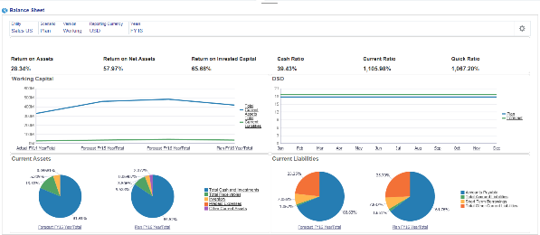

1. Click **Driver and Trend Based** vertical tab. You have the same consistent concept, drivers with adjustments as well as trends.

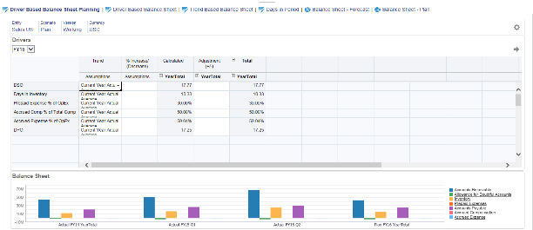

1. Review the results in the **Driver Based Balance Sheet**. Here are drivers for the balance sheet. You can add more drivers as necessary.
2. Click the **Trend Based Balance Sheet**. For any accounts on the Balance Sheet that are not driver-based, you can use trends.
3. Click the **Balance Sheet – Plan**. An out-of-box Balance Sheet report brings all of the relevant information together and automatically balances using increases/decreases to Short Term Investments and Short Term Borrowing.

## Exercise 7: Planning Using Cash Flow

EPBCS offers a configurable ‘framework’ for fully integrated Cash Flow, focusing on Cash from Operations.

1. Click the **Cash Flow** card either by clicking the Show/Hide line again or clicking on the **Navigator** icon in the upper left and clicking on the Cash Flow link. The **Cash Flow** Overview shows key metrics. The application supports both the Indirect and Direct Cash Flow methods.

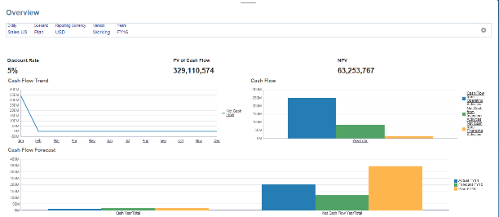

1. Click **Direct Entry** vertical tab (last).
2. Highlight **Cash Flow from Operating Activities** section. In this example, we are using the indirect method. The Cash Flow from Operations is calculated directly from the Balance Sheet so everything is dynamic.

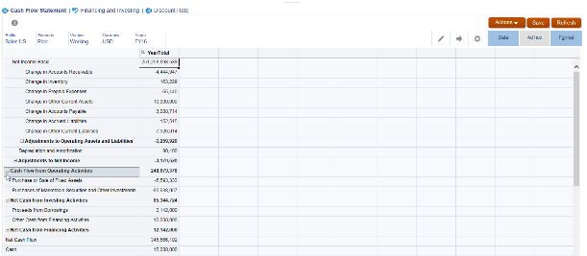

1. Click the **Financing and Investing** horizontal tab. The investing and finance section can be manually planned, or you can set up similar driver-based rules to automate this section.

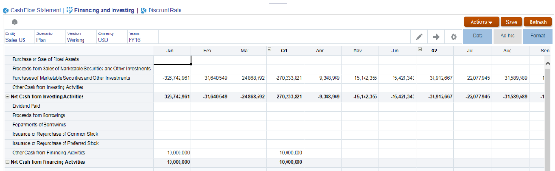

## Exercise 8: Analyzing Financials

1. Click the **Analysis** card either by clicking the Show/Hide line again or clicking on the **Navigator** icon in the upper left and clicking on the **Analysis** link. Here you can see the fully integrated financial statement dashboard – pulling together all the information from the enabled business processes.

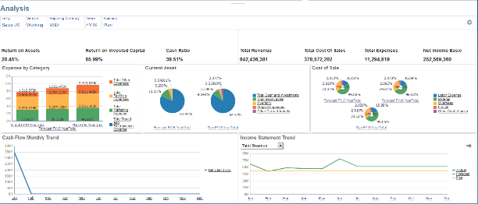

1. Click **Forms** vertical tab (last). Here is a list of all out-of-box reports. You can quickly configure more reports as well.

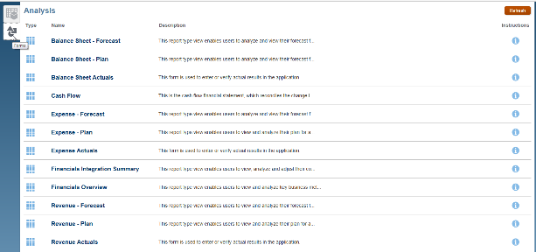

1. Go back to the Home page.
2. In the upper right corner, under the username click **Sign Out** to log off.

## Exercise 9: Shutting Down the Virtual Machine

**Note:** Do not power off the appliance by selecting Machine, then Close, and then Power off the machine in VM VirtualBox Manager because this action leaves the cloud service environment in an unknown state.

1. To shut down the running VM in its current state, from the login screen, click **Shut Down**. The PBCS_VirtualBox appliance is powered off when the VM operating system is shutdown.

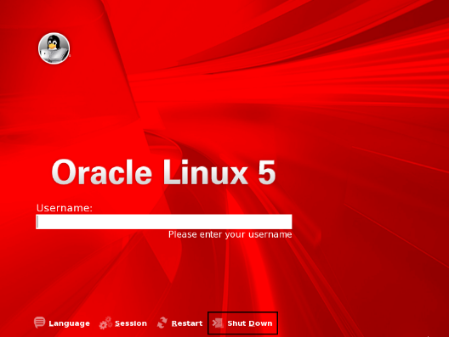

1. Click Shut Down.

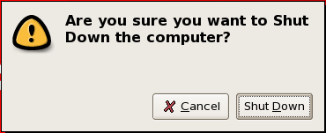

1. Once the PBCS_VirtualBox appliance is powered off, click **File** and then **Exit** to close Oracle VirtualBox.

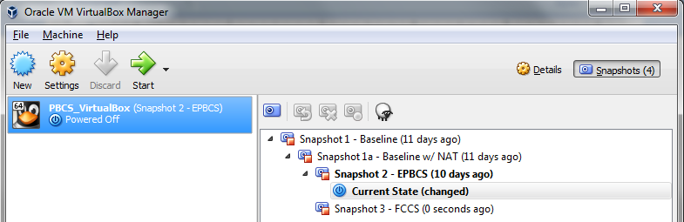

# Appendix: Creating Demo Environments

EPM Cloud is comprised of a portfolio of product services. For the most part, there is a separate demo environment for each service (e.g., EPRCS, ARCS, PCMCS). However, there is one demo environment that supports PBCS, EPBCS, and FCCS, the flagship products covering the two main EPM domains, planning and forecasting and financial close. Since these three services leverage the same common cloud platform, they can be stood up in the same demo environment.

**NOTE:** The demo environments simulate real-world use cases: one EPM application per service running on a single instance/environment. Built-in integration features and utilities allow the sharing of data across the EPM services and with other source systems. The ability to spin off multiple applications within the Oracle Cloud framework enables EPM for every function of the organization by leveraging an EPM architecture that is agile, configurable, and extensible.

Throughout this week you gained hands-on experience using an EPM Cloud VM based on the officially released version 16.09 from Development but modified for XWeek training purposes. Typically, EPM demo environments do not come with seeded demo applications. However, the VM you deployed on your laptop contains EPBCS and FCCS applications with pre-seeded and preconfigured content designed specifically to perform the labs written for XWeek in EMEA and JAPAC.

This appendix provides post-event guidance on how to create new demo environments on your own. The high level steps to follow:

1. DEMO ENVIRONMENT – Identify the type based on your needs.
2. DEMO ASSETS – Determine whether to build from scratch or leverage existing content.
3. DEMO SETUP – Build out and configure the application.

## 1.0 Types of EPM Demo Environments Available

There are several EPM demo resources available designed to support specific requirements. Select the demo resource that best aligns with your particular use case.

### Guided Demonstrations

**Quick Tours**

Quick Tours deliver quick introductory end-to-end experience for prospects by visualizing actual products and showing Oracle benefits via a self-guided experience. Quick Tours can be used by Sales as a convenient and quick demo vehicle, as an alternative to live demo systems, which hopefully triggers a lead.

From Demo Central:

[https://demo.oracle.com](https://demo.oracle.com/)

From Oracle Cloud SaaS Quick Tours:

<https://cloud.oracle.com/tryit>

**Click Through Demos (Swipe Demos)**

Click Through demos are short PowerPoint product screenshot demos that you can quickly and easily show on your PC or iPad in beautiful full-screen mode.

From Sales Central:

[https://salescentral.oracle.com/OracleDocCloudMeta/SalesCentral/public.html?4318#/pages/4356](https://salescentral.oracle.com/OracleDocCloudMeta/SalesCentral/public.html?4318)

From EPM Demo Dev Workspace:

<https://stbeehive.oracle.com/teamcollab/library/st/EPM+Demo+Development+Public/Documents>

### Live Demonstrations

**GSE Environments – Instant Demos and Deal Servers**

GSE offers many dedicated, live demo environments that you can reserve and use instantly: **Instant Demos** (up to 4 hours) and **Deal Servers** (3 days, can be extended).

**GSE Environments – Sandboxes**

Sandbox Live Environments are writeable, live demo environments that are shared with many people concurrently for experimentation and internal learning purposes, not to be used for customer-facing demonstrations. To keep them clean and usable, these sandbox environments are typically refreshed on a weekly or bi-weekly basis.

From Demo Central:

[https://demo.oracle.com](https://demo.oracle.com/)

**Portable Virtual Machines**

EPM Cloud Virtual Appliance (VM) supports PBCS, EPBCS, and FCCS only. Virtual Box image is developed and delivered by Development and is available for download. Performance is subject to limitations of the host laptop. VM runs very similarly to how the instances are deployed in GSE. However, there are small differences (e.g., need to authenticate with GSE Demo Central for Smart View access with GSE instances). The EPM VM Deployment document is posted in the Demo Dev workspace – similar process you followed when deploying the customized VM for this XWeek event. The VM appliance can be downloaded from Dev FTP site.

Oracle EPM Cloud Product Development periodically updates the EPM Cloud Virtual Machine Appliance for bug fixes and new product features, synchronized after the release of the latest generally available production version. So check for email announcements to know when a newer version is internally available to download.

EPM Cloud VM versions have expirations. So it is important you keep track of the version you are using and recommend deploying the latest version available. The VM cannot be upgraded. You need to download and deploy the new VM. To migrate any custom content, you can export applications from your existing VM using Lifecycle Management (LCM) and import into your new VM.

EPM Demo Development Beehive:

<https://stbeehive.oracle.com/teamcollab/library/st/EPM+Demo+Development+Public/Documents/Virtual+Machines>

## 2.0 EPM Demo Assets Available

In general, EPM demo environments do not come with seeded demo applications. This makes it easier to load whatever demo you need to use. Remember, one of the key value propositions is the ability to customize for specific customer requirements – enabling EPM for every function of the organization by leveraging an EPM architecture that is agile, configurable, and extensible.

**2016- OCT UPDATE**: EPM Cloud Instant Demo environments will have standard demo application seeded. What this means is when requesting instant demo environment, it will come bundled with seeded application and user accounts. There are some additional configuration steps required.

Demo assets are comprised of product content (LCM artifacts, data), setup instructions, and demo scripts (storyboard, show-and-tell walkthrough steps). Contributions by Demo Dev, GSE, and the larger Oracle community cover both horizontal and vertical content. Some demo assets are made available to partners. Leveraging existing content can help tremendously in quickly preparing for a customer-facing

sales session, especially if your demo needs to highlight specific features and functionality in more depth or showcase the product in the context of a specific industry.

EPM demo assets can be found in Demo Central ([https://demo.oracle.com](https://demo.oracle.com/)) under the Store tab. Search using **Filter by Product > Cloud Apps > EPM Cloud Performance Management.**

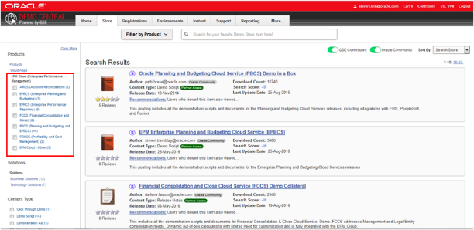

## 3.0 Setting up an EPM Demo Environment

If you are working with a pristine environment (GSE or Virtual Machine) and need to populate it with demo content, you can build from scratch creating an EPM application using the software’s application creation wizard, or load content into the environment using migration tools.

Most EPM cloud products leverage the built-in Lifecycle Management (LCM) functionality to load content. However, there are some exceptions where other tools are used – e.g., EPRCS uses database backup and restore procedures.

Using LCM, you follow these main steps:

1. Load users/groups LCM artifact
2. Load demo application LCM artifact(s)
3. Perform additional configuration steps after LCM loading

**Note**: The details under each step vary by EPM product and are updated frequently for fixes and enhanced content. Documents covering load and backup instructions and demo scripts are posted to GSE Demo Central.

## Example: EPBCS Demo Environment Setup

**Note:** The following instructions cover general steps to load and configure demo content. Minor differences will exist with updates to the software. Steps and screenshots provided are based on EPM Version 16.07 User Interface and are provided solely for illustrative purposes.

**CAUTION:** Only one EPM Cloud application can reside on the environment. Ensure the environment is empty. If necessary, remove any existing application. Log in using **epm_default_cloud_admin\epmDem0s.**

**For EPBCS Application:** Click the **Console** card. Select in the Actions drop-down list **Remove Application**. Click **Yes**. When EPBCS custom navigation flows get upgraded to the new User Interface (expected in release 16.10), the steps to remove an application will then be the same as FCCS below.

**For FCCS Application**: Click the **Application** card and then **Overview** card. Select in the Actions drop-down list **Remove Application**. Click **Yes.**

## Exercise 1: Load Enterprise Planning (EPBCS) User Groups and Roles

1. Log into the environment using **epm_default_cloud_admin\epmDem0s**. Click **Sign In**.

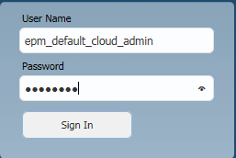

1. First it is recommended that you clear out any existing groups created from prior applications. Go to the **Navigator** by clicking the horizontal bars next to the Oracle logo located in the top left corner and select **Access Control**.

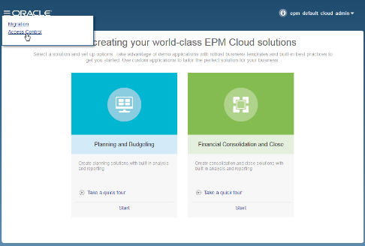

1. In the Manage Groups tab, remove any groups listed. For each group, select **Actions** and then **Delete.**

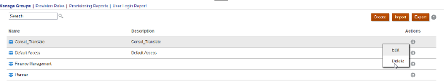

1. Go back to the **Navigator** by clicking the horizontal bars next to the Oracle logo located in the top left corner and select **Migration**.

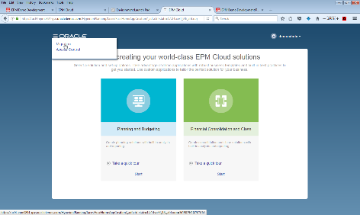

1. Go the **Snapshots** tab. Click **Browse** and locate the folder where you downloaded the LCM files on your local machine. Select the Users Groups Roles LCM (.zip file). Click **Upload**.

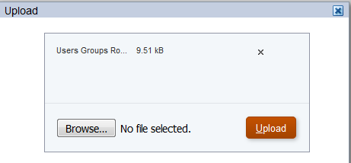

1. When the upload is successful, click OK.

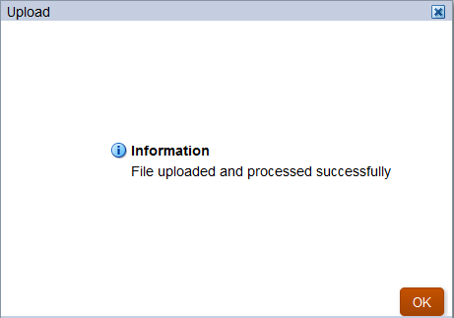

1. Highlight the Users Groups and Roles LCM package and click the **Actions** icon to select **Import**. This is a one-time only import and is only required when an environment has been refreshed. Click **OK**.

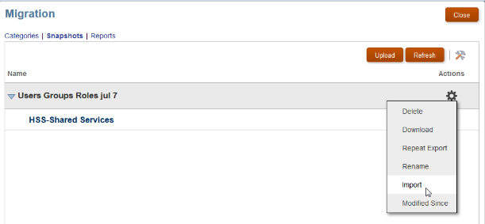

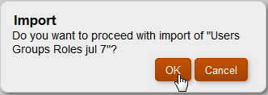

1. The import job should complete in a few seconds. Click **Close**.

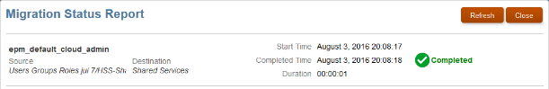

1. Click **Close** to close the Migration Status Report screen and then click **Close** to close the Migration screen. In the upper right corner, under the username click **Sign Out** to log off.

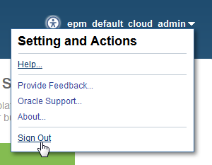

## Exercise 2: Load Enterprise Planning (EPBCS) Application

1. Now that the user groups and roles have been imported, you can import the application content. Log in as **demoadmin\epmDem0s**.

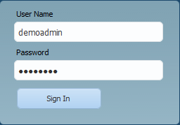

1. Go to the **Navigator** by clicking the horizontal bars next to the Oracle logo located in the upper left corner and select **Migration**.
2. Go the **Snapshots** tab. Click **Browse** and locate the folder where you downloaded the LCM files on your local machine. Select EPBCS Application LCM (.zip file). Click **Upload**.

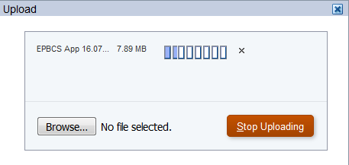

1. When the upload is successful, click **OK**.



1. Highlight the EPBCS App LCM package and click the **Actions** icon to select Import. Click **OK**.

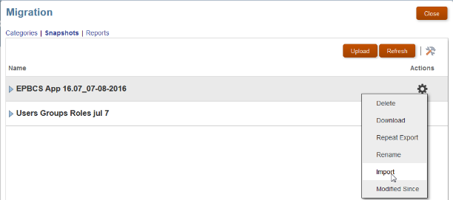

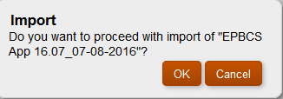

1. The import job will take 20-30 minutes. Click **Refresh** to update the status.

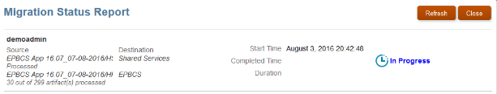

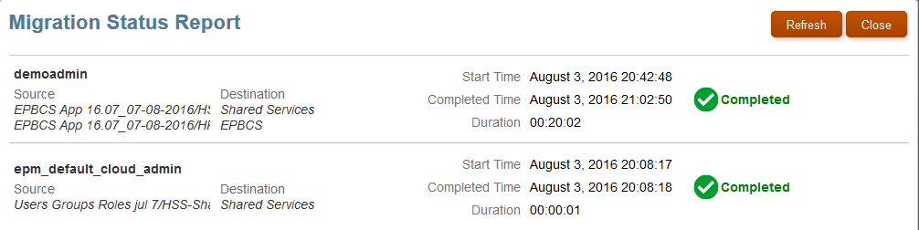

1. Repeat steps 3-6 to load incremental LCM Application artifacts (e.g., Strategic Workforce Planning, EPBCS Reports). Once imports are successfully completed, click **Close** to close the Lifecycle Management browser window log out of the application wizard screen.
2. Log out of the application.

## Exercise 3: Configure the Application (Pre-Demo Setup)

1. Log in again as **demoadmin\epmDem0s**.



1. You will see the seeded application. Denise Adams is the user id demoadmin.

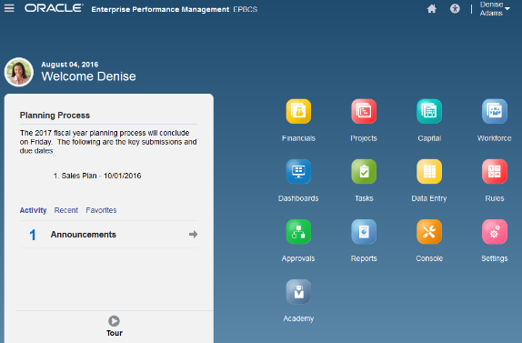

### Exercise 3-1: Change Application Maintenance Mode

1. You need to change the Application Maintenance Mode after importing the application. To do so, go to the **Navigator** by clicking the horizontal bars next to the Oracle logo located in the top left corner. Select **System Settings and Defaults** link.

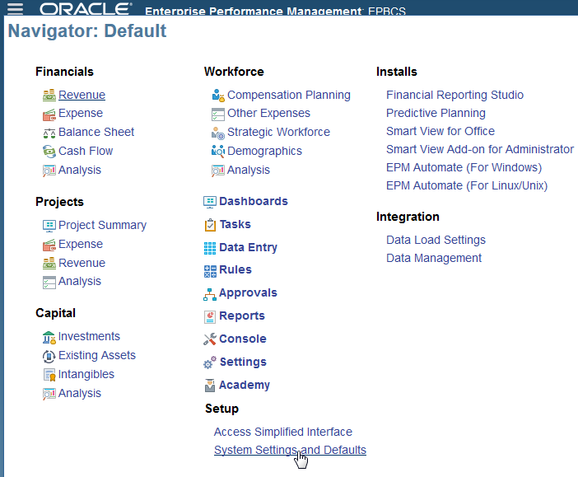

1. Set **Enable use of the application** for to All users. Click **Save** and then **OK**. Click on the Oracle logo in the upper left corner or the **Home** icon to return to the Home page.

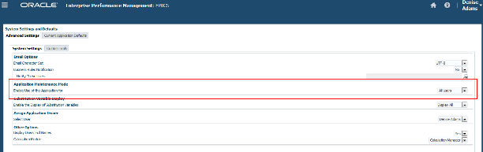

### Exercise 3-2: Activate Navigation Flows

1. A navigation flow controls what users see on the Home page. Activate navigation flows as needed. For example, to activate the Navigation Flow for Strategic Workforce Planning, click on the **Tools** cluster.

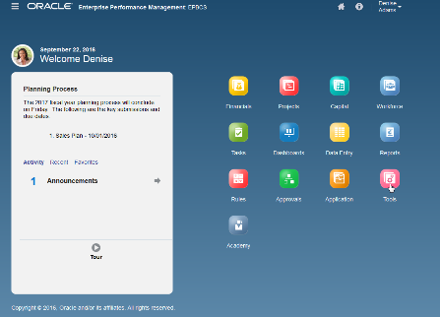

1. Click the **Navigation Flow** card.

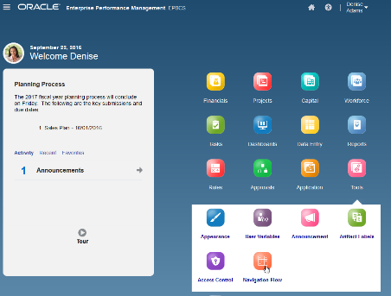

1. Click on the Inactive link for the **Demo01** navigation flow to change to **Activate**.

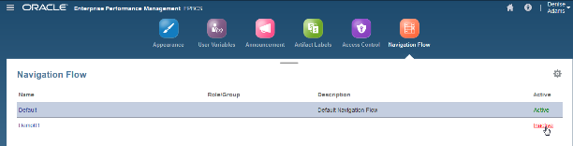

1. Either log out and back in or click on the Oracle logo or the Home icon, then click on the arrow next to the user name and select **Reload Navigation Flow**.

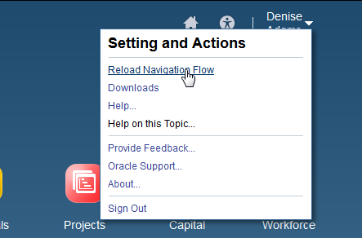

### Exercise 3-3: Refresh Database

1. A very important post-import step is to refresh the database. If you don’t do this, you will get an error in Workforce Planning when adding a new hire, change job status, etc. Click on the **Console** cluster and select the **Actions** button. Select **Refresh Database**.

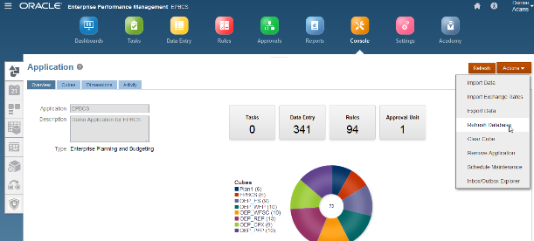

1. Click **Create, Refresh Database**, and then **Refresh**.

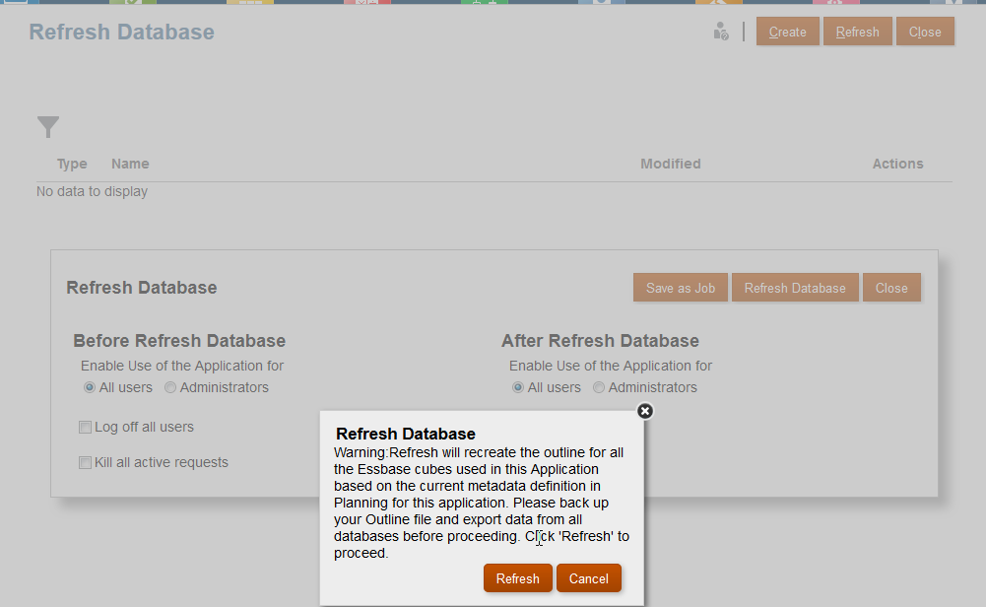

1. Click **Finish, Close**, and then **Close** when completed.

## Example: FCCS Demo Environment Setup

**Note:** The following instructions cover general steps to load and configure demo content. Minor differences will exist with updates to the software. Steps and screenshots provided are based on EPM Version 16.07 User Interface and are provided solely for illustrative purposes.

**CAUTION:** Only one EPM Cloud application can reside on the environment. Ensure the environment is empty. If necessary, remove any existing application.

1. Log in using **epm_default_cloud_admin\epmDem0s**.
2. Click the **Application** card and then **Overview** card. Select in the **Actions** drop-down list **Remove Application**. Click **Yes**.

## Exercise 1: Load Financial Consolidation and Close Cloud (FCCS) User

**Groups and Roles**

1. Log into the environment using **epm_default_cloud_admin\epmDem0s**. Click **Sign In**.



1. First it is recommended that you clear out any existing groups created from prior applications. Go to the **Navigator** by clicking the horizontal bars next to the Oracle logo located in the top left corner and select **Access Control**.



1. In the Manage Groups tab, remove any groups listed. For each group, select **Actions** and then **Delete**.



1. Go back to the **Navigator** by clicking the horizontal bars next to the Oracle logo located in the top left corner and select **Migration**.



1. Go the **Snapshots** tab. Click **Browse** and locate the folder where you downloaded the LCM files on your local machine. Select the Users Groups Roles LCM (.zip file). Click **Upload**.

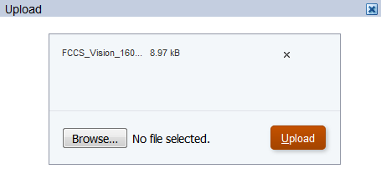

1. When the upload is successful, click **OK**.



1. Highlight the Users Groups and Roles LCM package and click the **Actions** icon to select **Import**. This is a one-time only import and is only required when an environment has been refreshed. Click **OK**.

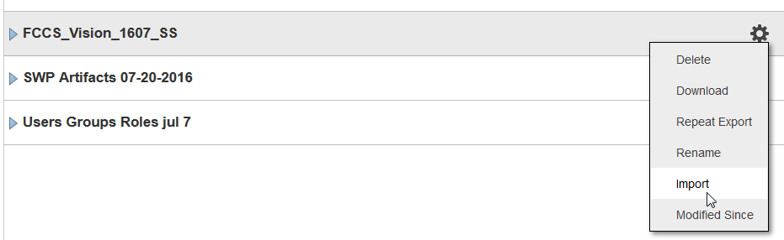

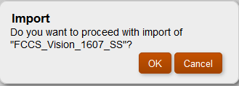

1. The import job should complete in a few seconds. Click **Close**.

## Exercise 2: Load Financial Consolidation and Close Cloud (FCCS)

**Application**

1. Go the **Snapshots** tab. Click **Browse** and locate the folder where you downloaded the LCM files on your local machine. Select FCCS Application LCM (.zip file). Click **Upload**.

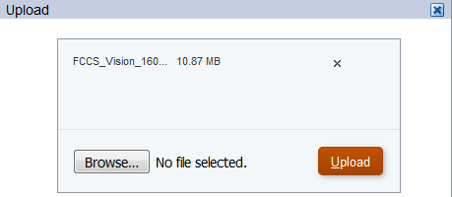

1. When the upload is successful, click **OK**.



1. Highlight the FCCS App LCM package and click the **Actions** icon to select Import. Click **OK**.

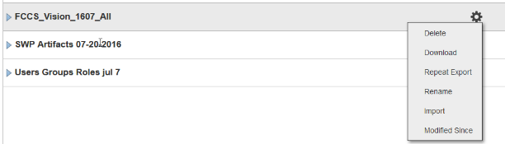

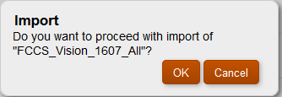

The import job will take 8-10 minutes (starting with version 16.09). Click **Refresh** to update the status.

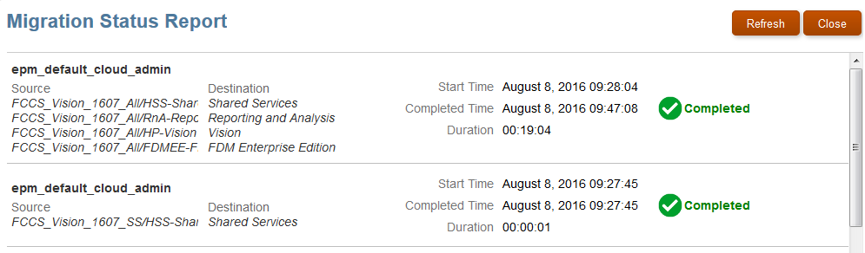

Click **Close** to close the Migration Status Report screen and then click **Close** to close the Migration screen. In the upper right corner, under the username click **Sign Out** to log off.

### Exercise 3: Configure the Application (Pre-Demo Setup)

1. Log in as **demoadmin\epmDem0s**.



1. You will see the seeded application. Denise Adams is the user id demoadmin.

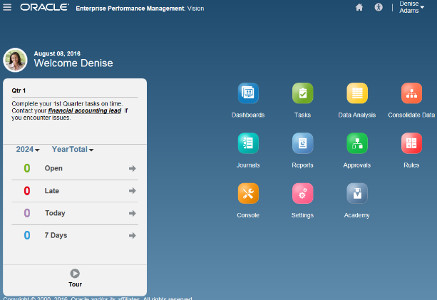

### Exercise 3-1: Change Application Maintenance Mode

1. You need to change the Application Maintenance Mode after importing the application. To do so, go to the **Navigator** by clicking the horizontal bars next to the Oracle logo located in the top left corner. Select **Applications Settings** link.

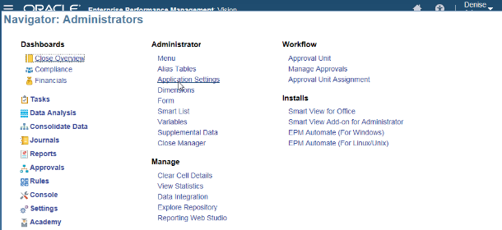

1. Set **Enable use of the application for** to All users. Click **Save** and then **OK**. Click on the Oracle logo in the upper left corner or the **Home** icon to return to the Home page.

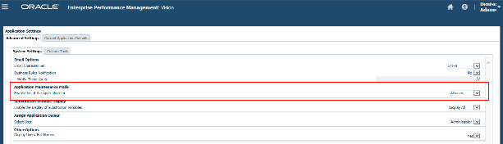

1. In the upper right corner, under the username click **Sign Out** to log off.

### Exercise 3-2: Update Announcement End Date (if needed)

Administrators can use Announcements to display a Home page messages and alerts to all Oracle Financial Consolidation and Close Cloud users. For any announcements seeded, you may need to adjust the ‘End Date’ to accommodate your demo needs.

1. Log in again as **Maria\epmDem0s**.

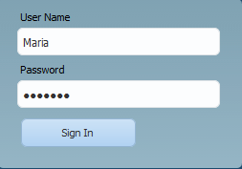

1. Click on the **Settings** card. Select the **Announcements** vertical tab. Click on **Qtr 1** announcement.

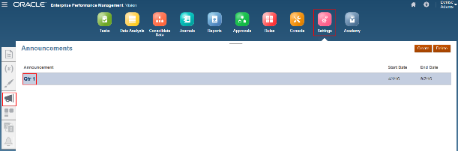

1. Update the **End Date** to a future date. Click on **Save and Close**.

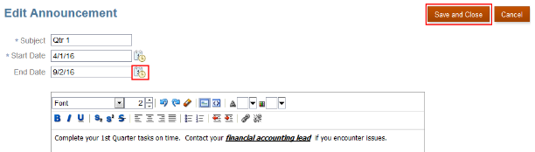

### Exercise 3-3: Deploy Schedule

There is no deployed schedule included with the demo content. It is required to deploy the schedule from the existing template and then execute several tasks to stage the demo.

1. Click the **Navigator** icon and select **Close Manager** under Administer column.
2. From the **Manage Templates**, you may have more than one schedule to choose from. Create a schedule from the Vision Monthly Close template. Click the **Create Schedule** icon.

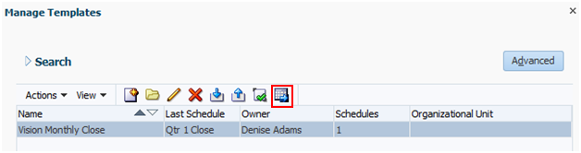

1. Name your schedule **Qtr 1 Close, Year=2016, Period =Mar, Day Zero Date** = a date that is before today’s date. The goal is to have tasks in different states that demo well – some late, some open, some pending. The Day Zero date you use should be customized to your demo needs using the FCCS pre-seeded application.

What date you use for Day Zero determines which tasks are late (<= Day -1) and which tasks will be considered started (=> Day 1). A task not started means you cannot act on it (e.g., submit, reject, approve). This means it will not be activated into the workflow until the start date arrives. **Bottom line, no matter your demo requirements, it is important when you create the schedule from a template, pick any date before today’s date, else all tasks will be pending and you cannot take any action on them.**

Note: The standard demo script recommends setting the Day Zero date to ensure the “Review Financial Reports” task assigned to Maria (Accounting Manager) will be started on or before your demo and to ensure Day 11 tasks will be started.

A good target is to have the “Review Financial Reports” task assigned to Maria / demoadmin started today or earlier. “Review Financial Reports” is a Day 9 task which means the start date for this task will be set 9 days out from the date you set Day Zero.

In the example below, if today is Aug 10, 2016 then for “Review Financial Reports” to be “started” today, counting backwards 9 business days (Sat and Sun excluded), makes Day Zero = Jul 28, 2016.

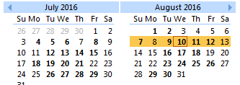

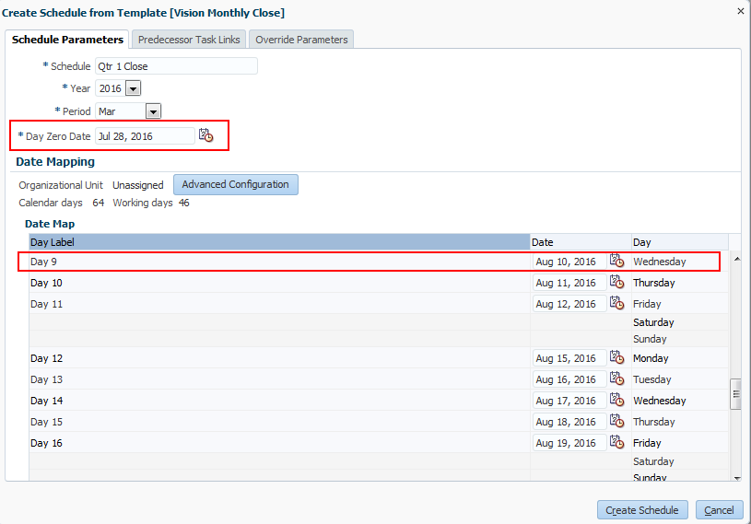

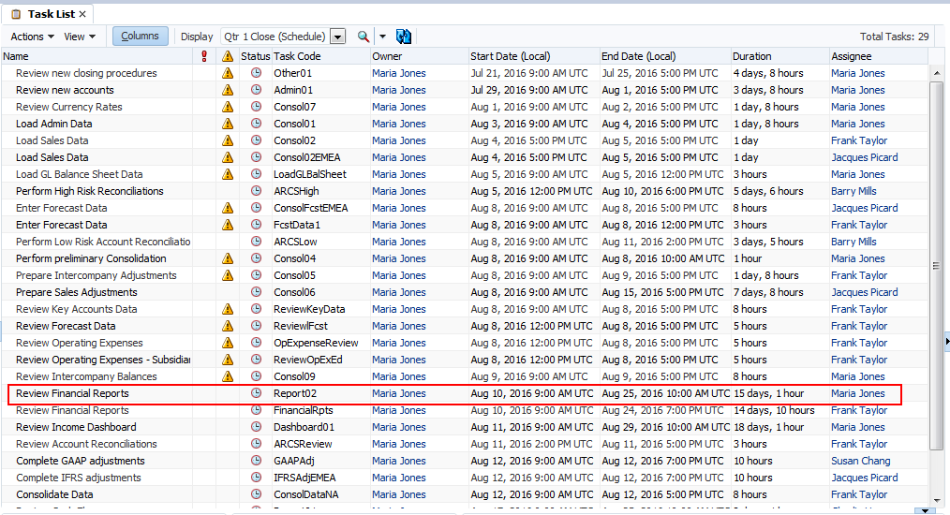

1. Click **Create Schedule**. When completed, click **OK** and then **Close**.

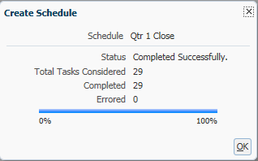

1. When you create a schedule, it has a status of Pending by default so that you can make final adjustments to it, and add, edit, or delete tasks. To run a schedule, you change the status from Pending to Open. When the schedule is opened, tasks begin to execute according to their definition. Status for tasks that have met their starting condition are set to Open, and task notifications are sent to their Assignees.

Select **Manage** and then select **Schedules**. Select the **Qtr 1 Close** schedule. Select **Actions** and then **Set Status**, or select the **Set Status drop-down**. Select **Open**.

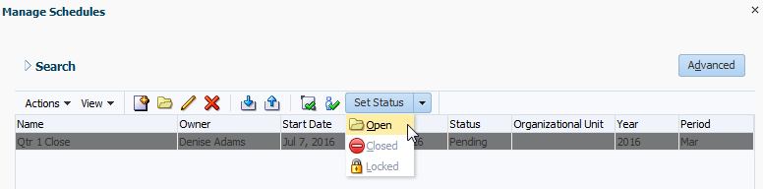

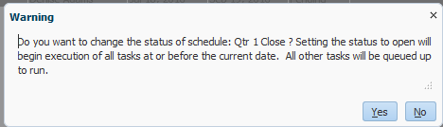

1. Click **Yes**.
2. Click **Close. Refresh**.

### Exercise 3-4: Submit Tasks

1. With the schedule just opened, no tasks have been acted on. In order to better simulate a close process in progress, you need to submit tasks logged in as each Assignee (Maria, Frank, Jacques, Barry).
   * + Log into FCCS with the **username\ epmDem0s** credentials.
     + Change user POV on the Task Panel: **Year = 2016, Period = Mar**. This drives what the entire user experiences in the interface.



* + - Click on **Tasks** card.
    - Click on the **Open with Me** icon to filter the list to the only the user’s tasks.

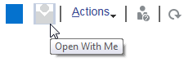

* + - Click on All tab to view all your tasks.

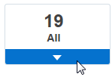

* + - For each user below, submit the following tasks to set them as Closed. Click each task or use the **Actions** drop-down list to open. Click **Submit**. Click **Yes**.

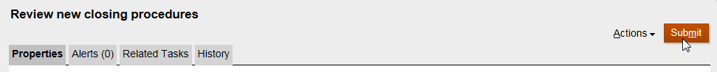

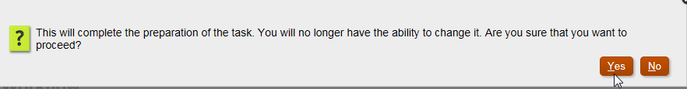

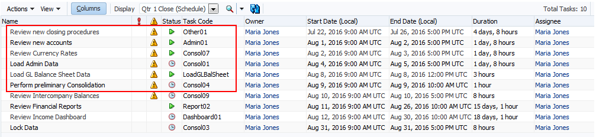

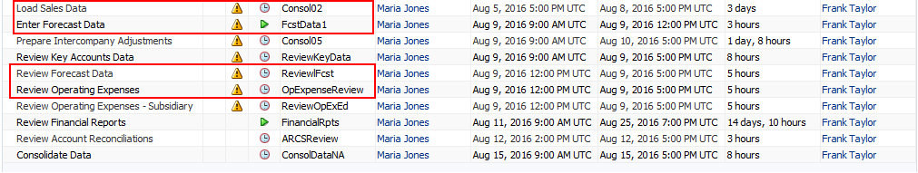



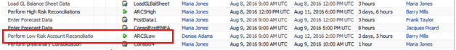

Note: Some tasks cannot be submitted until predecessors have been submitted first.

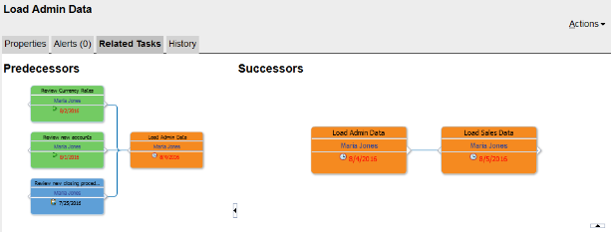

* + - Be sure to log off after you are done with each user.

1. Your submitted tasks should look like the schedule below (logon as Maria). There may be some slight variation depending on Day Zero setting.

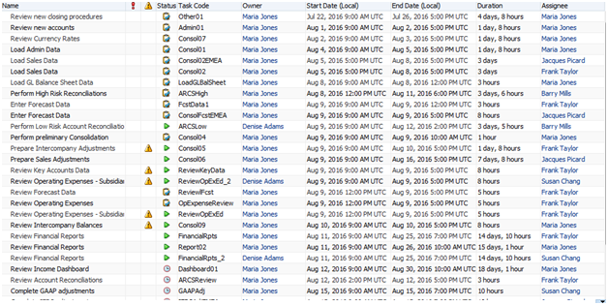

### Exercise 3-5: Reject Tasks

1. Set up Rejected Task: Perform High Risk Reconciliations. **In a different browser (e.g. Firefox or Chrome)**, log in as **Barry\epmDem0s**.
   * + Change **POV to 2016 Mar**.
     + Open and submit the **Perform High Risk Reconciliations** task. Click **Submit** and then **Yes**.



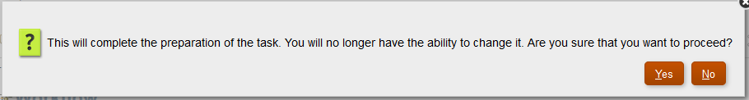

1. Back in the browser logged in as **Maria\epmDem0s** and **Reject** the Perform High Risk Reconciliations task as approver.



1. Back as Barry, add a comment in the comments section for the task and resubmit.
   * + Either click **Actions** in the upper right corner and select **Create Comment** in the drop-down list or in the Comments section, click the **Create Comment** icon.

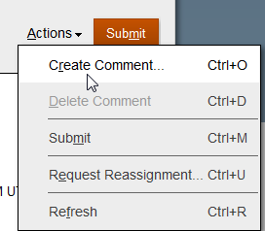



* + - For Perform High Risk Reconciliations task, enter: “High risk reconciliations have been completed.”Click **Submit**.

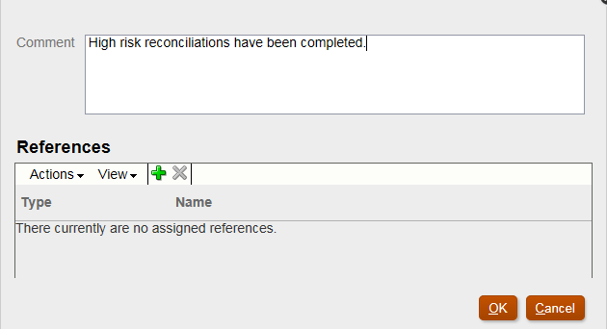

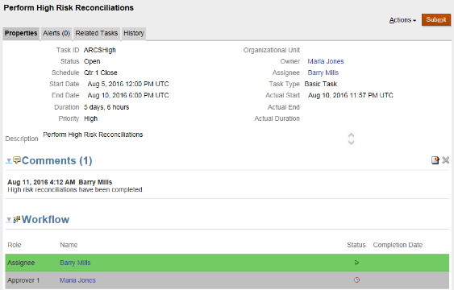

* + - As Barry, log off.

### Exercise 3-6: Load Data and Set Drill Through

1. Using Data Management, load data and set up drill through. Logged on as **Maria\epmDem0s**, go to **Navigator** and click **Data Integration**.

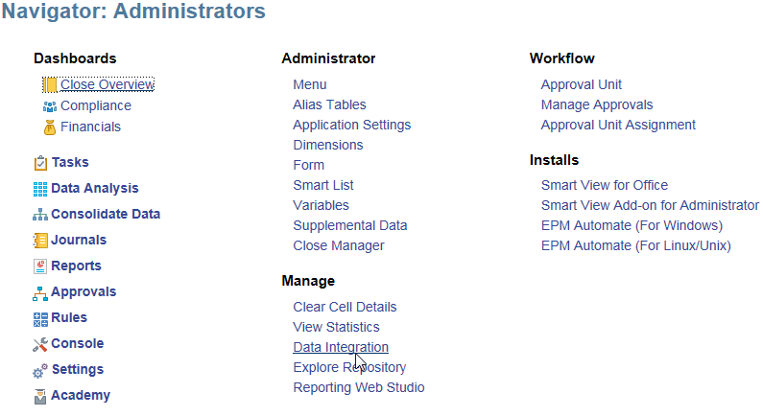

1. Under the **Setup** Tab, click **User Settings**. Set the following user settings and click **Save**:
   * + Default POV Location=Vision
     + Default POV Period = Mar-16
     + Default POV Category = Actual

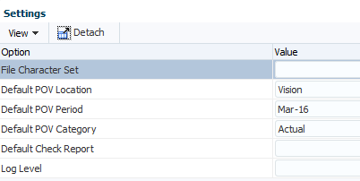

1. Under the **Workflow** tab, click **Data Load Rule**. Upload the Generic 2016 Jun.txt file to the inbox (download from XWeek portal).
   * + In the Details section under Source Options tab, click the **Select** button next to the File Name box.
     + Click the child inbox and **Upload** the file.

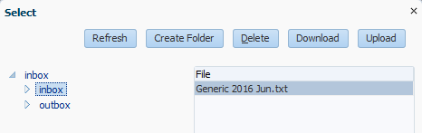

1. Load the data to FCCS. On **Workflow** tab, click **Data Load Workbench**. Run the Data Integration.
   * + Import Stage: Click **Import** link. Import Mode=Replace, Execution Mode=Online

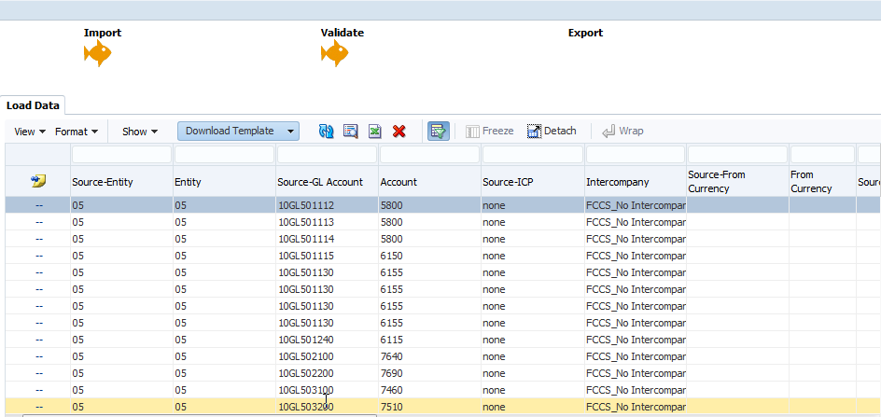

* + - Export Stage: Click **Export** link. Export Mode = Merge, Execution Mode=Online

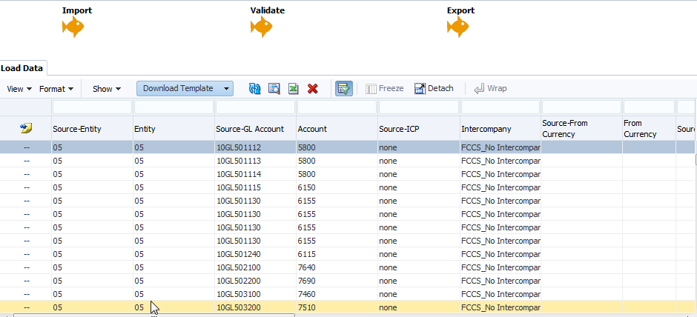

1. Click **X** to exit Data Management.

### Exercise 3-7: Set POV for Users

1. Set your POV for **Maria and Frank**. Log into FCCS with **the username\ epmDem0s** credentials.
2. The POV for the demo is Mar 2016. Entity = “01”-Operations. Set your POV in the following areas (click the → arrow key):
   * + **Task Panel on the Home Page**: 2016, Mar
     + Run the Set POV form under 1 Setup folder. Click **Data** card and locate the **Set POV** form.

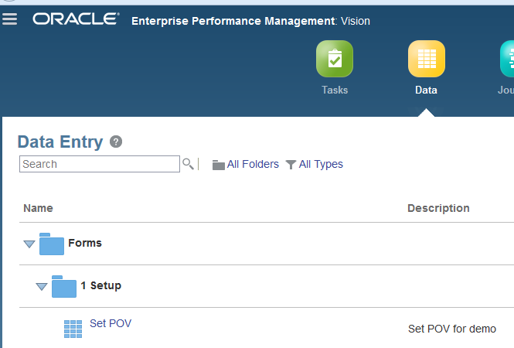

* + - Click the **Set POV** link to open the form.

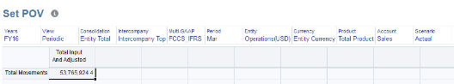

* + - Opening this report should set the POV for the following areas:
      * Journals Module: Actual, Mar, 2016
      * Dashboards
        + Close Overview: 2016, Mar / 2016, Mar, Qtr 1 Close/ 2016, Mar, Actual All
        + Compliance: 2016, Mar, Qtr 1 Close/2016, Mar, Actual, All
        + Financials: Income Dashboard: FY16, Periodic, Actual, Operations, Mar, Entity Currency
        + Financials: Operating Expense: FY16, Periodic, Operations, Mar
      * Intercompany Report: Actual, FY16, Mar, Periodic, Entity Input, Entity Currency
      * Financial Reporting reports: Mar, FY16, FCCS_Periodic, Entity Currency, Operations, Entity Input, Total Data Source, Total Movements, Intercompany Top, Local GAAP, Total Product (Note: The POV does not always stick and can revert to default members.)
    - Click **Close** to close the form.

### 4.0: Backing up EPM Demo Content

Best practice is to always backup your demos so that you can reuse in the future, share with colleagues, or if needed, restore on a different environment. You use Lifecycle Management to export the application artifacts from a source environment – the reverse of importing content into a target environment. LCM artifacts are exported as snapshots and then downloaded to a local machine.

**Note**: The following instructions cover general steps to back up demo content for most EPM Cloud services. Minor differences will exist with updates to the software. Steps and screenshots provided are based on EPM Version 16.09 User Interface and are provided solely for illustrative purposes.

1. To get to Lifecycle Management, click the **Application** card and then select **Migration**.
2. On the **Categories** tab, select the options you wish to back up or click **Select All** and click the Export button. If you wish to export or deselect specific artifacts for your export, you can click on one of the categories (e.g. Planning, Reporting, etc.) and select or deselect options. Select All will select all options listed.

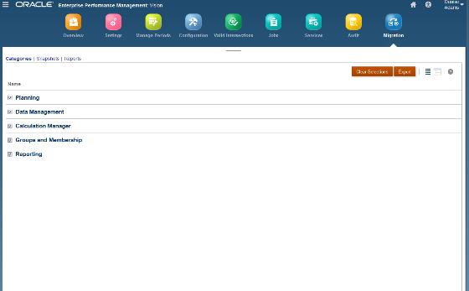

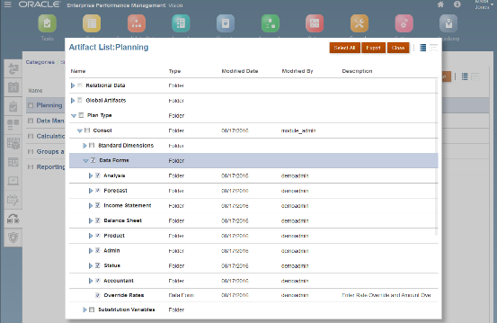

1. Give the artifact a new name and click **OK**.
2. When the migration is complete, click **Close**.
3. On the Snapshots tab, highlight the LCM snapshot. (You may need to click **Refresh**.) Click on the **Actions** icon and select **Download**. Save the file to your local machine.

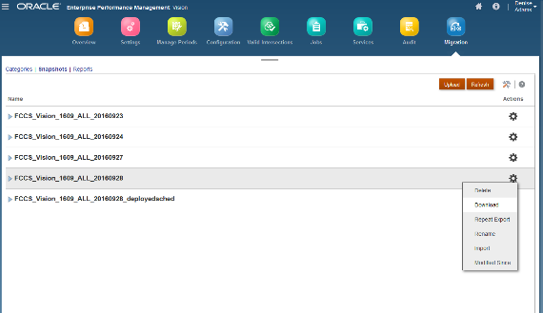

1. You can repeat a previous export operation to generate snapshots using the settings you used previously. On the **Snapshots** tab, highlight the existing LCM artifact, click on the **Actions** icon and select **Repeat Export**.

